Test Plan

**Test Objective**

For each type of birds, write a XXXBirdTester to verify whether its methods works correctly.

**Example**

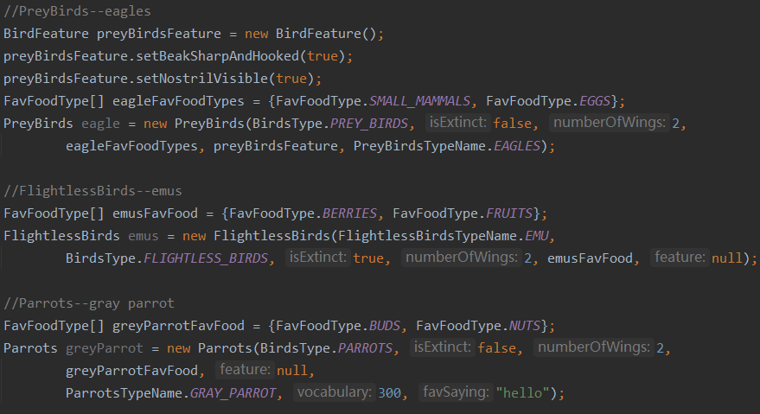

**Test Case**

BirdsMethodTest for each xxxBirdClass

* testGetBirdsType()
  + assertEqual()
* testGetIsExtinct()
  + assertEqual()
* testGetNumberOfWings()
  + assertEqual()
* testGetFavFood()
  + assertEqual()
* testGetFeature
  + assertEqual()
* testGetBirdName()
  + assertEqual()
* testIsNumberOfWingsValid()
  + IllegalAugumentException

ParrotsTest

* testGetVocabulary()
  + assertEqual()
* testIsVocabularyValid()
  + IllegalAugumentException
* testGetFavSaying()
  + assertEqual()

ShoreBirdsTest

* testGetBodyOfWaterType()
  + assertEqual()

WaterfowlBirdsTest

* testGetBodyOfWaterType()
  + assertEqual()